SEDL 7410
Repeat the following test cases for
- An express order. i.e send a IOC order and verify this cases.
- Send an DR order. i.e set the Routing property for a class to be DR-Site enabled.
TestCase1:

Set up the PDPM property by both the option and strategy Class Key .
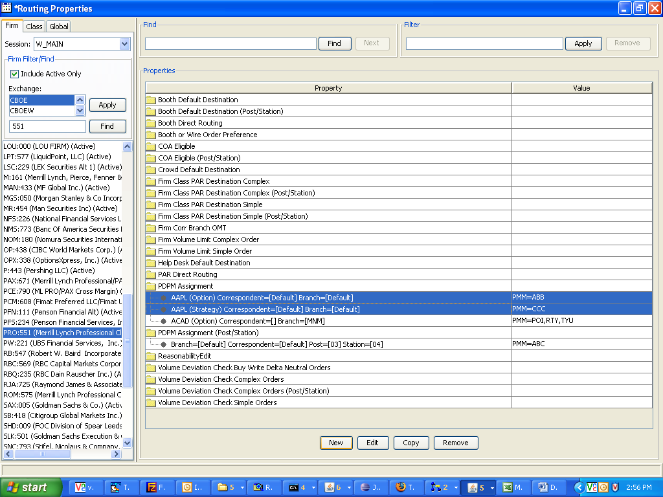
In this example, the property value by option class = ABB and by Strategy class is CCC.

Now route a Complex order from the trader GUI to trade server. Make sure that the firm volume limit, Volume Deviation and COA routing properties are set right.

Note down the branch and branchsequencenumber of this order.

Go to that particular BC where the class belongs to.
(For example: telnet atgqabc64, userid:atgtest6, password:atgtest6)
After logging in, you will be at the run_dir.
Type: loginDb W_MAIN
You will be at the sql prompt
Type:
select extensions from sbtorder where branch='BB' and branchsequencenumber=5;

You should see the PDPM value of the option key property that you had set (i.e. ABB)
You should NOT see the PDPM value of the strategy product (i.e CCC)

TestCase2:
Set up the PDPM property by post and station (in this example it is set to ABC). Remove the PDPM property by option class key.
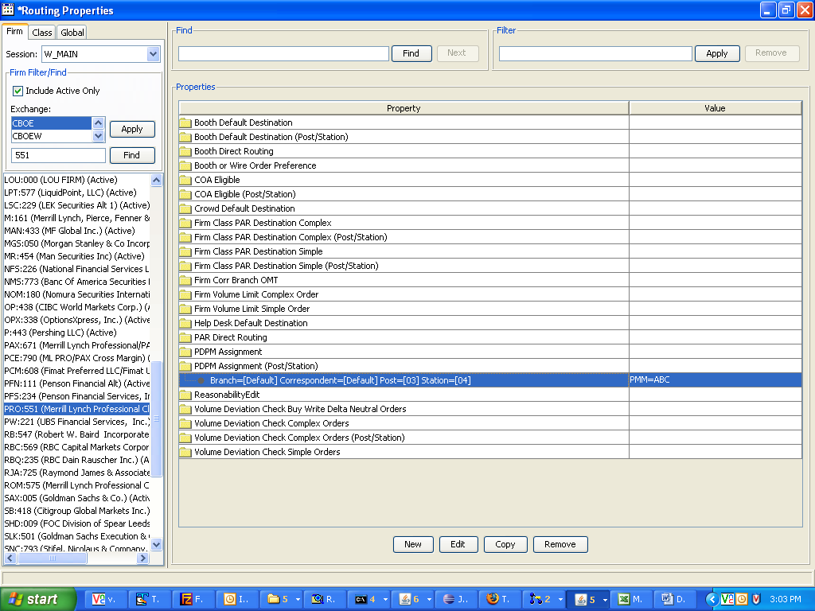
Now route a complex order from the trader GUI to trade server. Make sure that the firm volume limit, Volume Deviation and COA routing properties are set right.

Note down the branch and branchsequencenumber of this order.

Go to that particular BC where the class belongs to.
(For example: telnet atgqabc64, userid:atgtest6, password:atgtest6)
After logging in, you will be at the run_dir.
Type: loginDb W_MAIN
You will be at the sql prompt
Type:
select extensions from sbtorder where branch='BB' and branchsequencenumber=5;

You should see the PDPM value of the option key property that you had set (i.e. ABC)
You should NOT see the PDPM value of the strategy product (i.e CCC)

TestCase3:
Change the PDPM property by post and station to ABD.
Route an order and then run the sql query. You should see ABD as the value.

